Community Board SWOT Analysis

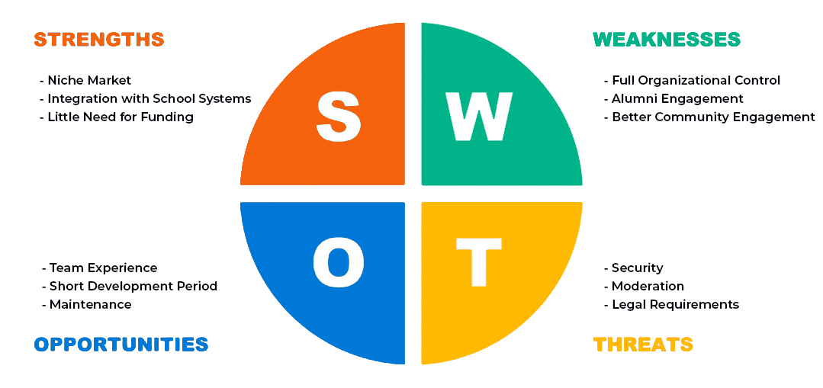

# Strengths

## Niche Market

Since we’re building this app directly for students and alumni of BYUI, there is essentially no competition.

## Integration with School Systems

This app is being developed for use by the school, and therefore would potentially be able to be integrated into their systems for managing user data.

## Little Need for Funding

The development team is all students and the majority of what we need for development is accessible without the need for additional funds.

# Weaknesses

## Team Experience

The development team is still learning how to program effectively and efficiently as a group. This could lead to longer than average development times or missing key features.

## Short Development Period

Due to short development times, we will largely be unable to test the product with focus groups or do alpha and beta testing. Bugs may get through unnoticed for a time.

## Maintenance

The app will require constant updates and support in order to stay relevant and functional. Future classes or individuals may need to be hired/recruited to provide upkeep.

# Opportunities

## Full Organizational Control

Due to the nature of the development, the school has full control over the finished product and its uses.

## Alumni Engagement

By incorporating alumni into the app, we allow for incredible networking opportunities for current students to be able to improve their prospects for the future.

## Better Community Engagement

Allows for both on-campus and online students to engage with each other in meaningful ways. Also helps to promote community events and get people out of their houses and interacting with other students.

# Threats

## Security

Due to lack of experience, data security may be an issue in the future.

## Moderation

Moderation would need to be done on a volunteer basis, if there aren’t enough moderators, or they are busy, potentially harmful or inappropriate content may slip through the cracks.

## Legal Requirements

There are various laws pertaining to privacy and personal information. We may need to include a disclosure on how information is being used or a consent form of some kind (terms of service, etc).